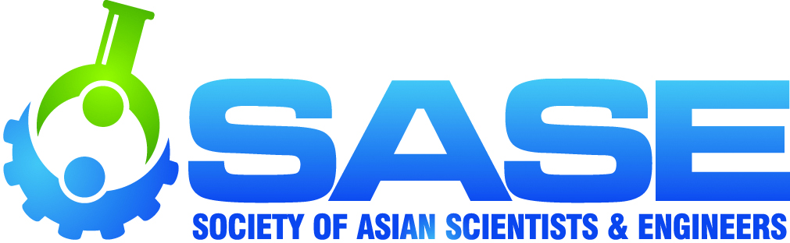
Society of Asian Scientists & Engineers (SASE)
2015 National Conference and Career Fair
October 8-10, 2015
(Hilton Americas – Houston, TX)

Company Name_________________________________________________________________________________

Contact Name___________________________________________ Title___________________________________

Address_________________________________________ City_______________________ State____Zip________

Email________________________________Phone______________Fax______________Web_________________

SPONSORSHIP OPPORTUNITIES:

__CONFERENCE CO-LEAD SPONSOR - $32,000 each, maximum 3 (Website banner ad on SASE conference page, Organizational Advisory Council (OAC) membership, Two ad pages in SASE Magazine (either an advertising spread or single ad page and full page editorial profile of Asian-American executive), Quad career fair booth, One workshop, Eight full conference registrations, 2 – 3 minute video shown at Gala, One pre-conference email blast, One “Visit Us” sign outside career fair, One Facebook post, Two interview booths)

__ORGANIZATIONAL ADVISORY COUNCIL – OAC - $20,000 (Double career fair booth, Full page ad in SASE Magazine, Two interview booths, Full year access to resume database, Two face-to-face OAC meetings per year, Six full conference registrations, One Email blast to conference participants or SASE members, One workshop at national conference, Choice of one SASE Regional Conference sponsorship (includes mention on regional conference website, table at event, one registration for event), Scrolling logo on SASE homepage, Logo (or listing) on OAC page in SASE Magazine, Ten SASE professional memberships)

__Gala–Dinner Sponsor - $28,000 (Welcome, Introduce event speaker, Full page in SASE Magazine, Double career fair booth, Four full conference registrations, Distribution of company materials)

__Lunch Sponsor - $24,000 (Welcome, Introduce event speaker, Full page in SASE Magazine, Double career fair booth, Two full conference registrations, Distribution of company materials)

__Collegiate Leadership Seminar - ($25,000 – one sponsor, $20,000 each – two sponsors) (Provide presenter - subject to SASE approval), One workshop, Full page ad in SASE Magazine, Double career fair booth, Four full conference registrations)

__Breakfast Sponsor - $18,000 (Welcome, Introduce event speaker, Full page in SASE Magazine, Double career fair booth, Two full conference registrations, Distribution of company materials)

__Thursday Night Reception Sponsor - $16,000 (Welcome to event attendees, Full page in SASE Magazine, Double career fair booth, Two full conference registrations, Distribution of company materials)

__Break Sponsor - $13,000 (Two Breaks, mid-Morning and mid-Afternoon, Full page in SASE Magazine, Double career fair booth, Two full conference registrations, Distribution of company materials)

__Registration Desk/Conference Check-In - $16,000 (Extra signage at check-In (Physical and online check-In), Full page in SASE Magazine, Double career fair booth, Two full conference registrations)

__Name Tags - $18,000 (Company logo on each attendee name tag, Full page in SASE Magazine, Double career fair booth, Two full conference registrations)

__Resume Room – ($25,000 – one sponsor, $17,000 each – two sponsors) (Your company reps offer resume critiques, Full page in SASE Magazine, Double career fair booth, Two full conference registrations)

__Conference Tote Bag - $18,000 (Distributed to all full conference attendees, Company logo, Full page in SASE Magazine, Career fair booth, Two full conference registrations, Distribution of company materials)

__Business Center - $15,000 (Four computing stations for attendees with central printing, Full page in SASE Magazine, Double career fair booth, Two full conference registrations) Providing 4 computers with central printing optional ($1,000 discount)

__Student Travel - $12,000 (1 per region) (Support students from your region’s travel to conference, Student badge ribbons saying “I’m here because of (your company)”, Full page in SASE Magazine, Double career fair booth, Two full conference registrations)

PAGE 1 of 2

Society of Asian Scientists & Engineers (SASE)
2015 National Conference and Career Fair
October 8-10, 2015
(Hilton Americas – Houston, TX)

SPONSORSHIP OPPORTUNITIES (CONTINUED):

__Bus Sponsorship - $10,000 (Dallas – Houston, Austin - Houston, Approximately 54 students per bus, Company signage, “Captive audience for trip”, Full page ad in SASE Magazine, Career fair booth, Two full conference registrations)

__SASE Photo Studio Sponsor - $12,000 (Company logo on SASE “Step and Repeat” Photo Studio banner, Full page ad in SASE Magazine, Career fair booth, Two full conference registrations)

__Game Night - $15,000 (Welcome Game Night attendees, Logo on any Game Night materials, Full page ad in SASE Magazine,
Career fair booth, Two full conference registrations)

__Friday Reception “Speed Networking” - $12,000 (Welcome to event attendees, Double career fair booth, Full page ad in SASE Magazine, Two full conference registrations)

__Sponsored Workshops - $12,000 (Welcome attendees, Supply workshop presenter, Half page in SASE Magazine, Career fair booth, Two full conference registrations)

__Sponsored Panels - $10,000 (Welcome attendees, Provide one panelist, Half page in SASE Magazine, Career fair booth, Two Full Conference registrations)

__Academic Lead Sponsor - $10,000 (Double career fair booth, 10 full conference registrations, unlimited career fair registrations, representative at OAC meetings, insert in tote bags, Full page ad in SASE Magazine, Logo on website, One email blast, One Facebook post)

CAREER FAIR OPPORTUNITIES:

__Standard Career Fair Booth - $6,950 - $6,450 if paid by July 2 (Career fair booth, Half page in SASE Magazine, One full conference registration)

__Government Sponsor - $5,950 (Career fair booth, Half page in SASE Magazine, One full conference registration)

__Academic Sponsor - $1,500 (Career fair booth, Half page in SASE Magazine, One career fair registration)

__Double Career Fair Booth - $11,500 - $11,00 if paid by July 2 (10’x20’, Full page in SASE Magazine, Two full conference registrations)

__Triple Career Fair Booth - $15,000 (10’x30’, Full page in SASE Magazine, Two full conference registrations)

__Quad Career Fair Booth - $18,500 (20’x20’, Full page in SASE Magazine, Three full conference registrations)

ADDITIONAL OPPORTUNITIES:
(Must be purchased with a sponsorship package)

__Interview Booths - $300 each Number of Booths Needed_____
__Hospitality Suites - $2,750 (Based on availability, Sponsor provides food and non-alcoholic drinks)
__Community Service Event - $4,000 (Event signage)
__Product Insert in Tote Bag - $1, 000 (Included in conference tote bags)
__Sport Water Bottles for Attendees - $10,000 (Includes your company logo, Included in conference tote bags)
__Poster Outside Career Fair on Easel - $1,500 (Large Sign (22”x28”) with your logo and message)
__Email Blast to Registrants - $3,000 (Limit 10, plus Lead and OAC Sponsors) (You draft email to registrants. Sent within 10 days of conference)

Authorized Signature_______________________________Title_____________________________Date_______
Fax completed form to: 509-752-6094 or email to rene.avendano@saseconnect.org. Checks payable to SASE. Mail check to: PO Box 147139, Edgewater, CO 80214. Sponsorships will be considered reserved once payment is received. For Sponsorship and Payment Questions, contact René Avendaño, ph: (562-496-4428)
Booth Info: All Booths are 10’ w X 10’ exhibit spaces unless specified otherwise. Includes pipe and drape, one six foot table, two chairs, one wastebasket. Please, no more than three representatives per single booth. Additional representatives in single booths can be arranged upon request.
Cancellation and Payment Policy: No cancellation after payment received. All sponsorships must be prepaid before the beginning of the National Conference and Career Fair.
PAGE 2 of 2

